Practicals 3 Solutions: Network meta-analysis

Course on network meta-analysis 2018 Kea, Greece

## R packages

We will use the package **readxl** to import excel data and the packages **netmeta** to run network meta-analyses.

library(readxl)  
library(netmeta)

## Datasets

### Acute mania dataset

The file AcuteMania.xls comprises data from the secondary efficacy outcome of the network meta-analysis published in Cipriani et al. (2011).

AcuteMania = read_excel("~/_mydrive/Teaching/Kea NMA course/Practicals/AcuteMania.xls")  
AcuteMania = as.data.frame(AcuteMania)  
str(AcuteMania)

## 'data.frame': 105 obs. of 5 variables:  
## $ treatment: chr "ARI" "PLA" "ARI" "PLA" ...  
## $ r : num 155 63 72 42 89 72 49 23 110 49 ...  
## $ n : num 253 131 137 135 175 172 130 132 267 134 ...  
## $ studyid : num 1 1 2 2 3 3 4 4 5 5 ...  
## $ rob : num 2 2 2 2 2 2 2 2 2 2 ...

This is a full network and includes 47 studies comparing the effectiveness of active drugs and placebo. The outcome is efficacy dichotomous (responders r out of randomized n).

The dataset is in *long format*; that is, each row is a study arm. The same id is used to show that different arms belong to the same study (studyid). This format is popular and we encourage researcher to use it when collecting data from studies.

The variable ‘rob’ contains information about the risk of bias (1 means low, 2 moderate and 3 high risk of bias).

### Schizophrenia dataset

The file Leucht.xls comprises data from the primary outcome (efficacy) of the systematic review and network meta-analysis published in Leucht et al. (2013).

Leucht = read_excel("~/_mydrive/Teaching/Kea NMA course/Practicals/Leucht.xls")  
Leucht = as.data.frame(Leucht)  
str(Leucht)

## 'data.frame': 247 obs. of 7 variables:  
## $ year : num 1969 1970 1970 1971 1972 ...  
## $ id : num 196 39 40 41 42 168 168 168 70 115 ...  
## $ study : num 196 39 40 41 42 168 168 168 70 115 ...  
## $ treat1: chr "CPZ" "CPZ" "CPZ" "CPZ" ...  
## $ treat2: chr "PBO" "PBO" "PBO" "PBO" ...  
## $ effect: num -0.284 -0.873 -0.565 -0.514 -0.18 ...  
## $ se : num 0.367 0.398 0.351 0.331 0.349 ...

We present only the primary outcome (efficiacy). The standardized mean difference for the change in the symptomes scale between the first treatment (treat1) and the second treatment (treat2), Negative values favor treat1.

## Analysis of the network comparing antimanic drugs

Let’s first get some information on the studies included in the network meta-analysis.

Which treatment is the most frequently studied?

table(AcuteMania$treatment)

##   
## ARI ASE CARB DIV HAL LAM LITH OLA PAL PLA QUE RIS TOP ZIP   
## 7 1 3 8 8 1 8 13 2 36 7 5 1 5

How many studies have more than two arms?

table(table(AcuteMania$studyid))

##   
## 2 3   
## 36 11

Because our data are in long format we need first to transform them into the *contrast-based format* with a single pairwise comparison per row (this format is required by R function netmeta). This transformation can be done by using the pairwise function.

AcuteManiaPair = pairwise(treat = treatment, event = r, n = n,  
 data = AcuteMania, studlab = studyid, sm = "OR")

Now compare the two datasets by looking at the first three studies. What format have they been converted to?

AcuteMania[AcuteMania$studyid < 4, ]

## treatment r n studyid rob  
## 1 ARI 155 253 1 2  
## 2 PLA 63 131 1 2  
## 3 ARI 72 137 2 2  
## 4 PLA 42 135 2 2  
## 5 ARI 89 175 3 2  
## 6 HAL 72 172 3 2

AcuteManiaPair[as.numeric(AcuteManiaPair$studlab) < 4, 1:9]

## studlab treat1 treat2 TE seTE event1 n1 event2 n2  
## 1 1 ARI PLA 0.5348306 0.2173352 155 253 63 131  
## 12 2 ARI PLA 0.8972087 0.2526573 72 137 42 135  
## 23 3 ARI HAL 0.3627931 0.2162238 89 175 72 172

What is now presented in the new variables TE and seTE?

## Network plot

To plot the network you need first to create an object of class netmeta by running the command. Note: if we used pairwise to transform our data, we can use this object as the single argument to the netmeta function.

net1 = netmeta(AcuteManiaPair)

Then use the following netgraph command to produce a network plot

netgraph(net1)

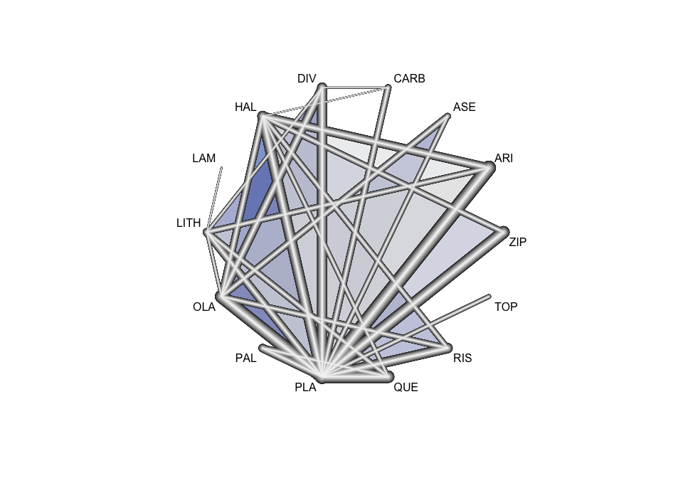

Check the help file for the netgraph command to see the options you have.

Now re-create a plot by weighting the nodes and edges according to the number of studies evaluating each treatment and comparison.

netgraph(net1, plastic = FALSE, multiarm = FALSE, thickness = "number.of.studies",  
 points = TRUE, cex.points = table(AcuteMania$treatment) / 2, col = 1)

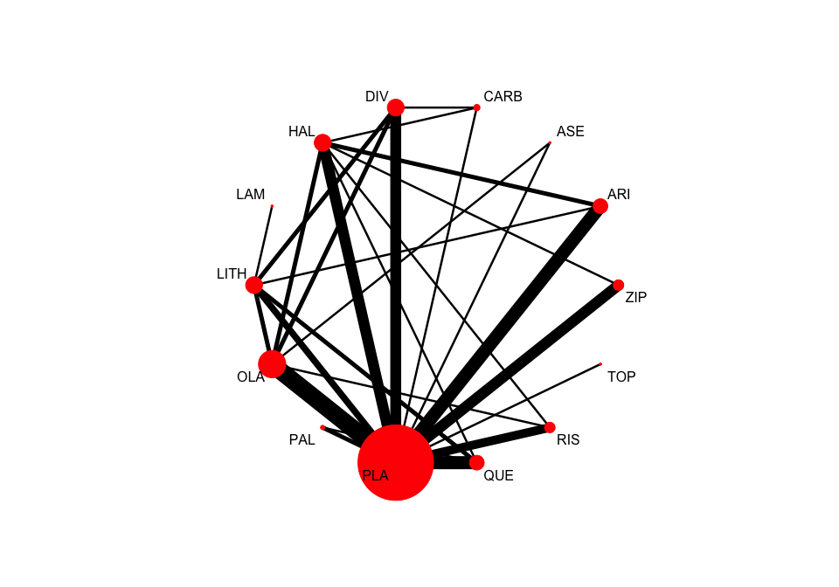

**Optional:** You can create 3-D plots using the **rgl** library.

# install.packages("rgl")  
# netgraph(net1, plastic = FALSE, multiarm = FALSE, dim = "3d", col = 1)

## Performing a network meta-analysis

The netmeta command that we run before estimates NMA treatment effects using default options. Let us define what we exactly want in terms of analysis using the arguments (see the list of arguments in the help file). Let us run only a random effects meta-analysis and use Placebo as the reference to present the results.

net1 = netmeta(AcuteManiaPair, sm = "OR", ref = "PLA",  
 comb.fixed = FALSE, comb.random = TRUE)  
summary(net1, digits = 2)

## Number of studies: k = 47  
## Number of treatments: n = 14  
## Number of pairwise comparisons: m = 69  
## Number of designs: d = 30  
##   
## Random effects model  
##   
## Treatment estimate (sm = 'OR', comparison: other treatments vs 'PLA'):  
## OR 95%-CI  
## ARI 1.9923 [1.5275; 2.5985]  
## ASE 1.6934 [0.9111; 3.1474]  
## CARB 2.4719 [1.3616; 4.4875]  
## DIV 1.9765 [1.4346; 2.7229]  
## HAL 2.2527 [1.7180; 2.9537]  
## LAM 1.3484 [0.2765; 6.5761]  
## LITH 1.7697 [1.2461; 2.5135]  
## OLA 2.1775 [1.7251; 2.7485]  
## PAL 1.7244 [1.0901; 2.7275]  
## PLA . .  
## QUE 1.9410 [1.4613; 2.5782]  
## RIS 2.3615 [1.7001; 3.2801]  
## TOP 0.7778 [0.3524; 1.7165]  
## ZIP 1.3717 [0.9929; 1.8950]  
##   
## Quantifying heterogeneity / inconsistency:  
## tau^2 = 0.0759; I^2 = 49.1%  
##   
## Tests of heterogeneity (within designs) and inconsistency (between designs):  
## Q d.f. p-value  
## Total 88.39 45 0.0001  
## Within designs 33.62 17 0.0094  
## Between designs 54.77 28 0.0018

What does the output matrix show?

Which drug presents the largest response rate compared to Placebo?

How much is the heterogeneity? How has it being estimated and under which assumptions?

Compare the results with those reported in Figure 3 by Cipriani et al. (2011). Note: Cipriani et al. reported placebo versus active while we calculated active versus placebo. To see the estimates for placebo versus drug simply set the argument baseline.reference=FALSE.

net1 = netmeta(AcuteManiaPair, sm = "OR", ref = "PLA",  
 comb.fixed = FALSE, comb.random = TRUE, baseline.reference = FALSE)  
summary(net1, digits = 2)

## Number of studies: k = 47  
## Number of treatments: n = 14  
## Number of pairwise comparisons: m = 69  
## Number of designs: d = 30  
##   
## Random effects model  
##   
## Treatment estimate (sm = 'OR', comparison: 'PLA' vs other treatments):  
## OR 95%-CI  
## ARI 0.5019 [0.3848; 0.6547]  
## ASE 0.5905 [0.3177; 1.0976]  
## CARB 0.4046 [0.2228; 0.7344]  
## DIV 0.5060 [0.3673; 0.6970]  
## HAL 0.4439 [0.3386; 0.5821]  
## LAM 0.7416 [0.1521; 3.6170]  
## LITH 0.5651 [0.3979; 0.8025]  
## OLA 0.4592 [0.3638; 0.5797]  
## PAL 0.5799 [0.3666; 0.9173]  
## PLA . .  
## QUE 0.5152 [0.3879; 0.6843]  
## RIS 0.4235 [0.3049; 0.5882]  
## TOP 1.2857 [0.5826; 2.8374]  
## ZIP 0.7290 [0.5277; 1.0072]  
##   
## Quantifying heterogeneity / inconsistency:  
## tau^2 = 0.0759; I^2 = 49.1%  
##   
## Tests of heterogeneity (within designs) and inconsistency (between designs):  
## Q d.f. p-value  
## Total 88.39 45 0.0001  
## Within designs 33.62 17 0.0094  
## Between designs 54.77 28 0.0018

There are some small numerical differences to the ORs reported in the paper. Why?

Several elements are stored under the *net1* object.

The heterogeneity standard deviation is estimated as

round(net1$tau, 3)

## [1] 0.276

and I-square (total) is

paste(round(net1$I2), "%", sep = "")

## [1] "0%"

## Presenting the results from a network meta-analysis

### League table

To obtain a league table using the NMA object *net1* use the netleague function.

leaguetable = netleague(net1, digits = 2)  
leaguetable

## League table (random effects model):  
##   
## ARI . .  
## 1.18 [0.60; 2.30] ASE .  
## 0.81 [0.42; 1.54] 0.69 [0.29; 1.62] CARB  
## 1.01 [0.67; 1.52] 0.86 [0.43; 1.69] 1.25 [0.65; 2.41]  
## 0.88 [0.64; 1.23] 0.75 [0.39; 1.46] 1.10 [0.58; 2.09]  
## 1.48 [0.30; 7.31] 1.26 [0.23; 6.86] 1.83 [0.34; 9.95]  
## 1.13 [0.75; 1.70] 0.96 [0.47; 1.93] 1.40 [0.70; 2.78]  
## 0.91 [0.65; 1.29] 0.78 [0.42; 1.43] 1.14 [0.60; 2.14]  
## 1.16 [0.68; 1.96] 0.98 [0.45; 2.12] 1.43 [0.68; 3.04]  
## 1.99 [1.53; 2.60] 1.69 [0.91; 3.15] 2.47 [1.36; 4.49]  
## 1.03 [0.70; 1.50] 0.87 [0.44; 1.72] 1.27 [0.66; 2.46]  
## 0.84 [0.56; 1.28] 0.72 [0.36; 1.43] 1.05 [0.53; 2.06]  
## 2.56 [1.11; 5.90] 2.18 [0.80; 5.95] 3.18 [1.18; 8.56]  
## 1.45 [0.96; 2.19] 1.23 [0.61; 2.48] 1.80 [0.92; 3.54]  
##   
## . 1.16 [0.71; 1.89] .  
## . . .  
## 0.42 [0.08; 2.10] 0.80 [0.11; 5.82] .  
## DIV . .  
## 0.88 [0.58; 1.32] HAL .  
## 1.47 [0.29; 7.32] 1.67 [0.34; 8.30] LAM  
## 1.12 [0.72; 1.74] 1.27 [0.83; 1.95] 0.76 [0.16; 3.57]  
## 0.91 [0.64; 1.28] 1.03 [0.75; 1.43] 0.62 [0.13; 3.05]  
## 1.15 [0.66; 2.00] 1.31 [0.77; 2.21] 0.78 [0.15; 4.05]  
## 1.98 [1.43; 2.72] 2.25 [1.72; 2.95] 1.35 [0.28; 6.58]  
## 1.02 [0.67; 1.55] 1.16 [0.80; 1.68] 0.69 [0.14; 3.42]  
## 0.84 [0.53; 1.31] 0.95 [0.64; 1.42] 0.57 [0.11; 2.87]  
## 2.54 [1.08; 5.97] 2.90 [1.25; 6.69] 1.73 [0.29; 10.19]  
## 1.44 [0.92; 2.27] 1.64 [1.11; 2.43] 0.98 [0.20; 4.95]  
##   
## 1.09 [0.54; 2.19] . .  
## . 0.69 [0.35; 1.35] .  
## . . .  
## 0.78 [0.32; 1.92] 0.77 [0.47; 1.27] .  
## . 1.21 [0.67; 2.16] .  
## 0.76 [0.16; 3.57] . .  
## LITH 0.62 [0.26; 1.50] .  
## 0.81 [0.55; 1.20] OLA .  
## 1.03 [0.58; 1.80] 1.26 [0.76; 2.11] PAL  
## 1.77 [1.25; 2.51] 2.18 [1.73; 2.75] 1.72 [1.09; 2.73]  
## 0.91 [0.61; 1.35] 1.12 [0.78; 1.61] 0.89 [0.55; 1.45]  
## 0.75 [0.47; 1.20] 0.92 [0.64; 1.33] 0.73 [0.42; 1.28]  
## 2.28 [0.96; 5.41] 2.80 [1.23; 6.39] 2.22 [0.89; 5.53]  
## 1.29 [0.80; 2.07] 1.59 [1.07; 2.35] 1.26 [0.72; 2.20]  
##   
## 1.77 [1.32; 2.37] . .  
## 2.04 [0.96; 4.35] . .  
## 3.10 [1.58; 6.09] . .  
## 2.16 [1.48; 3.18] . .  
## 2.26 [1.58; 3.23] 1.72 [0.79; 3.73] 0.95 [0.47; 1.93]  
## . . .  
## 2.28 [1.43; 3.64] 0.70 [0.39; 1.25] .  
## 1.90 [1.43; 2.52] . 1.20 [0.60; 2.40]  
## 1.57 [0.96; 2.59] 1.25 [0.64; 2.45] .  
## PLA 0.51 [0.37; 0.69] 0.40 [0.27; 0.58]  
## 0.52 [0.39; 0.68] QUE .  
## 0.42 [0.30; 0.59] 0.82 [0.53; 1.26] RIS  
## 1.29 [0.58; 2.84] 2.50 [1.08; 5.79] 3.04 [1.29; 7.15]  
## 0.73 [0.53; 1.01] 1.42 [0.92; 2.17] 1.72 [1.09; 2.72]  
##   
## . .  
## . .  
## . .  
## . .  
## . 2.05 [1.03; 4.08]  
## . .  
## . .  
## . .  
## . .  
## 1.29 [0.58; 2.84] 0.68 [0.48; 0.95]  
## . .  
## . .  
## TOP .  
## 0.57 [0.24; 1.33] ZIP

This command produces a list with several object. You can obtain the league table in an exportable format (a database) and export it in a .csv file

write.csv(leaguetable$random, "leaguetable-random.csv", row.names = FALSE)

This file can be opened, for example, with Excel or LibreOffice.

**Optional:** You can also directly export a league table to an Excel file.

# install.packages("WriteXLS")  
# library(WriteXLS)  
# WriteXLS(leaguetable$random, ExcelFileName = "leaguetable-random.xls",  
# SheetNames = "leaguetable (random)", col.names = FALSE)

### Forest plots

The function forest.netmeta will, as expected, produce forest plots of NMA estimated effect sizes against the reference. The reference can be re-specified using the ‘ref’ argument.

forest(net1)

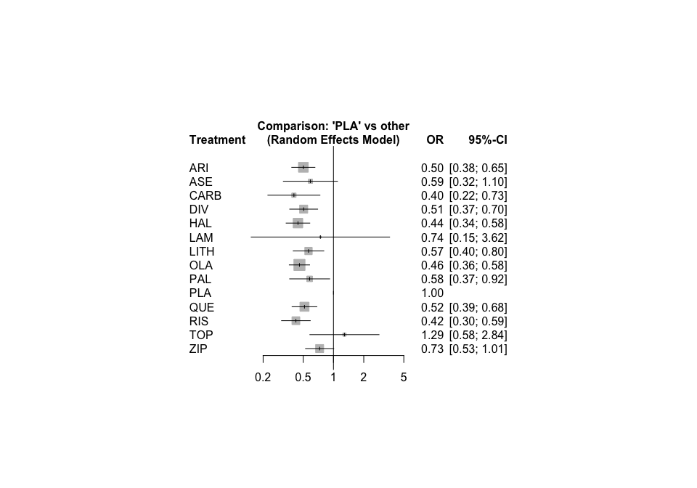

forest(net1, ref = "HAL")

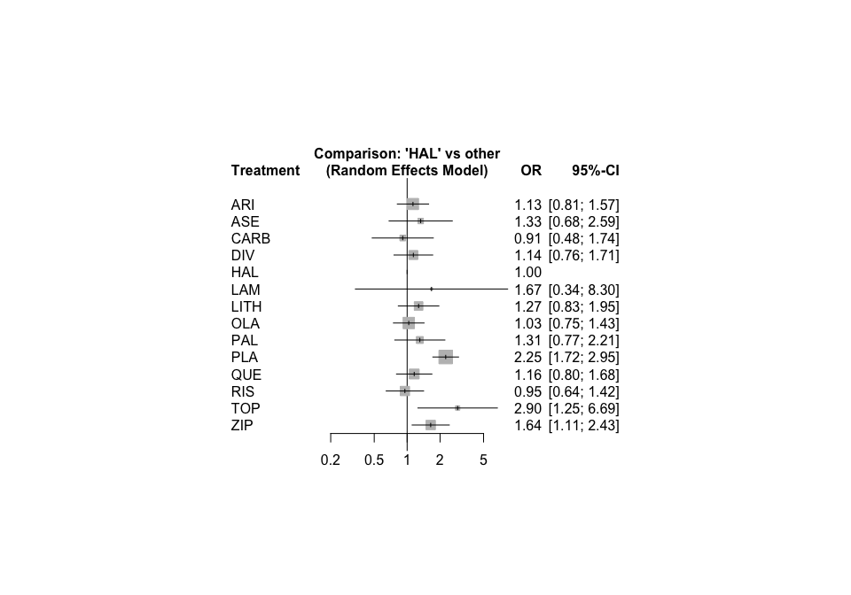

Which are the three most effective interventions compared to placebo?

Are there any differences between active interventions?

It is always useful to see the effect sizes in a consistent order, e.g. increasing

forest(net1, sortvar = TE)

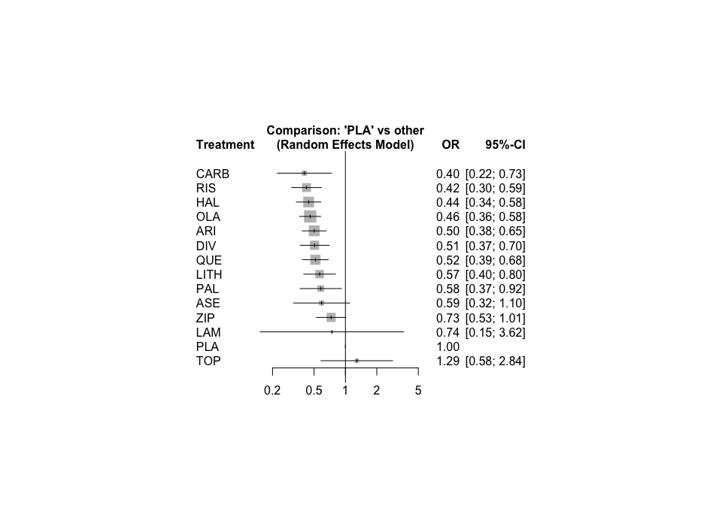

The variable ‘k’ stored in *net1* contains the number of direct comparisons. We can plot them in the forest plot.

forest(net1, sortvar = TE,  
 leftcols = c("studlab", "k"), leftlabs = c("Drug", "Direct\nstudies",  
 xlab = "Response to treatment", smlab = "NMA random effects"))

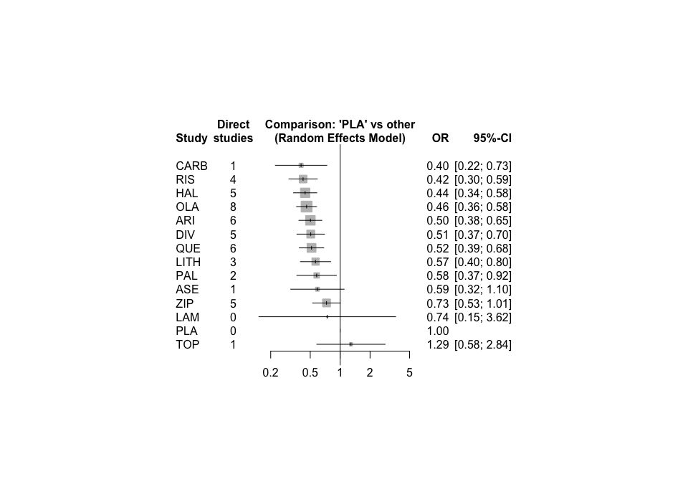

### Ranking treatments

The function netrank uses a transformation of the p-value to derive P-scores which are equivalent to SUCRA values.

netrank(net1, small = "bad")

## P-score  
## RIS 0.8002  
## CARB 0.7873  
## HAL 0.7608  
## OLA 0.7227  
## ARI 0.6007  
## DIV 0.5918  
## QUE 0.5715  
## LITH 0.4643  
## PAL 0.4552  
## ASE 0.4551  
## LAM 0.3852  
## ZIP 0.2492  
## PLA 0.0905  
## TOP 0.0655

Which intervention has the highest probability of “beating” all other treatments?

You can even add the P-scores in the forest plot and sort the summary ORs accordingly:

forest(net1,  
 rightcols = c("effect", "ci", "Pscore"),  
 rightlabs = "P-Score", sortvar = -Pscore, small = "bad",  
 xlab = "Response to treatment", smlab = "Active drug vs placebo")

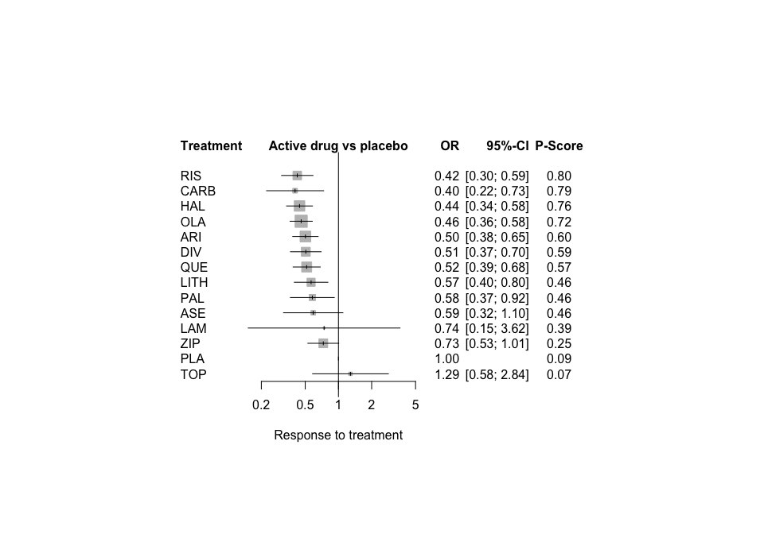

## Sensitivity analysis

When we created AcuteManiaPair we lost the information about risk of bias (this feature will be available in a future version of package **netmeta**). We can use the following two commands to copy the risk of bias column from the AcuteMania dataset (long format) to AcuteManiaPair (contrast-based format).

data.rob = AcuteMania[!duplicated(AcuteMania$studyid), c("studyid", "rob")]  
AcuteManiaPair = merge(AcuteManiaPair, data.rob, by.x = "studlab", by.y = "studyid")

The first command expects that the AcuteMania dataset is ordered by the study number (studyid) which is the case.

As you see there are studies only at low or moderate risk of bias.

table(AcuteManiaPair$rob)

## < table of extent 0 >

Cipriani et al. (2011) have excluded any studies at high risk of bias from the systematic review.

Let us perform a network meta-analysis using studies only at low risk of bias. Note: for this command we have to explicitly state the first five arguments instead of using AcuteManiaPair (this will also be changed in a future version of package **netmeta**).

net2 = netmeta(TE, seTE, treat1, treat2, studlab, data = AcuteManiaPair, subset=c(rob.x==1),  
 sm = "OR", ref = "PLA", comb.fixed = FALSE, comb.random = TRUE)

summary(net2, digits = 2)

## Number of studies: k = 13  
## Number of treatments: n = 9  
## Number of pairwise comparisons: m = 19  
## Number of designs: d = 11  
##   
## Random effects model  
##   
## Treatment estimate (sm = 'OR', comparison: other treatments vs 'PLA'):  
## OR 95%-CI  
## DIV 2.0486 [1.2131; 3.4597]  
## HAL 3.1608 [1.7166; 5.8200]  
## LITH 2.4550 [0.9078; 6.6393]  
## OLA 2.2324 [1.4092; 3.5364]  
## PAL 1.1370 [0.5062; 2.5540]  
## PLA . .  
## RIS 1.7524 [0.6793; 4.5204]  
## TOP 0.7778 [0.3152; 1.9189]  
## ZIP 1.8437 [1.1020; 3.0847]  
##   
## Quantifying heterogeneity / inconsistency:  
## tau^2 = 0.1251; I^2 = 56.8%  
##   
## Tests of heterogeneity (within designs) and inconsistency (between designs):  
## Q d.f. p-value  
## Total 18.52 8 0.0176  
## Within designs 3.59 2 0.1661  
## Between designs 14.93 6 0.0208

As you see only 9 of 14 treatments and 19 of 69 pairwise comparisons are represented in this subnetwork.

Is there evidence that the network that includes only low risk of bias studies is more homogeneous?

## Analysis of the network comparing antispychotic drugs

The schizophrenia dataset Leucht is available in the contrast-based format. Accordingly, we do not have to use pairwise to transform the dataset.

Note: Some of the SMDs (variable ‘effect’) or their standard errors (variable ‘se’) have been approximated from other data presented in the paper (such as p-values) and hence, they might not appear to be internally consistent in the multi-arm trials. Hence, you shall use the argument tol.multiarm=0.075 to have netmeta running.

net3 = netmeta(effect, se, treat1, treat2, study, data = Leucht,  
 sm = "SMD", ref = "PBO", comb.fixed = FALSE, comb.random = TRUE,  
 tol.multiarm = 0.075)

Then, present and interpret the results.

summary(net3)

## Number of studies: k = 169  
## Number of treatments: n = 16  
## Number of pairwise comparisons: m = 247  
## Number of designs: d = 63  
##   
## Random effects model  
##   
## Treatment estimate (sm = 'SMD', comparison: other treatments vs 'PBO'):  
## SMD 95%-CI  
## AMI -0.6513 [-0.7743; -0.5284]  
## ARI -0.4275 [-0.5213; -0.3337]  
## ASE -0.3737 [-0.5032; -0.2443]  
## CLO -0.8459 [-1.0033; -0.6885]  
## CPZ -0.3670 [-0.5251; -0.2089]  
## HAL -0.4461 [-0.5080; -0.3842]  
## ILO -0.3219 [-0.4291; -0.2148]  
## LURA -0.3264 [-0.4467; -0.2060]  
## OLA -0.5838 [-0.6462; -0.5214]  
## pal -0.4906 [-0.5989; -0.3823]  
## PBO . .  
## QUE -0.4288 [-0.5138; -0.3439]  
## RIS -0.5538 [-0.6214; -0.4861]  
## SER -0.3873 [-0.5195; -0.2550]  
## ZIP -0.3913 [-0.4895; -0.2931]  
## ZOT -0.4866 [-0.6696; -0.3036]  
##   
## Quantifying heterogeneity / inconsistency:  
## tau^2 = 0.0110; I^2 = 31.7%  
##   
## Tests of heterogeneity (within designs) and inconsistency (between designs):  
## Q d.f. p-value  
## Total 281.24 192 < 0.0001  
## Within designs 139.67 118 0.0846  
## Between designs 139.93 74 < 0.0001

forest(net3)

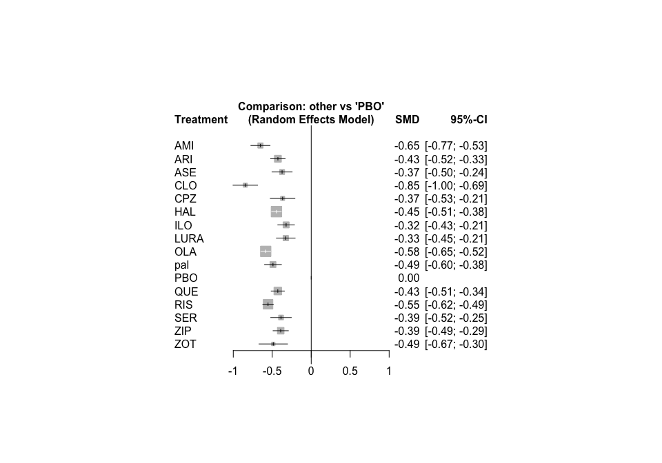

netrank(net3)

## P-score  
## CLO 0.9984  
## AMI 0.9158  
## OLA 0.8471  
## RIS 0.7880  
## pal 0.6485  
## ZOT 0.6169  
## HAL 0.5447  
## QUE 0.4784  
## ARI 0.4723  
## ZIP 0.3542  
## SER 0.3502  
## ASE 0.3125  
## CPZ 0.3039  
## LURA 0.1942  
## ILO 0.1750  
## PBO 0.0000

## References

* Cipriani A et al. (2011): Comparative efficacy and acceptability of antimanic drugs in acute mania: a multiple-treatments meta-analysis. *The Lancet*, **378**(9799), 1306-15.
* Leucht S et al. (2013): Comparative efficacy and tolerability of 15 antipsychotic drugs in schizophrenia: a multiple-treatments meta-analysis. *The Lancet*, **382**(9896), 951-62.